**Semester Project**

**Online Book Store**

Fall 2023

CSE-423L Web Engineering

Submitted by: **Ashfaq Ahmad**

Registration No: **19PWCSE1795**

Class Section: **B**

Student Signature: ______________

Submitted to:

**Eng. Usman Malik**

**July** 08, 2023

**Department of Computer Systems Engineering**

**University of Engineering and Technology, Peshawar**

**Project Title:**

Online Book Store

**Project Description:**

The Book Store Website is an online platform where users can register, log in, browse available books, place orders, and communicate with the admin. The website also provides administrative functionalities, allowing the admin to manage books, accept orders, set book prices, and control the entire website.

**Features:**

**User Registration and Login:**

Users can create an account by registering themselves on the website.

Once registered, users can log in using their credentials for access to the full functionality of the website.

**Preview:**

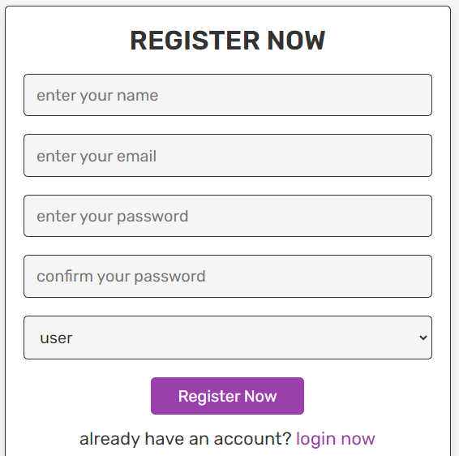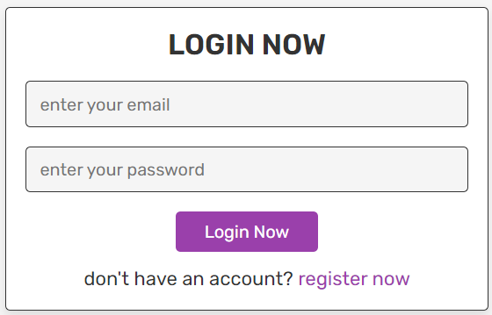

**Book Catalog:**

The website displays a catalog of available books.

Users can browse through different book categories, view book details, and check their availability.

 

**Order Placement:**

Users can select books they wish to order and specify the quantity.

The website provides a user-friendly interface to add books to the cart and proceed to the checkout process.

Users can review their order details before confirming the purchase.

  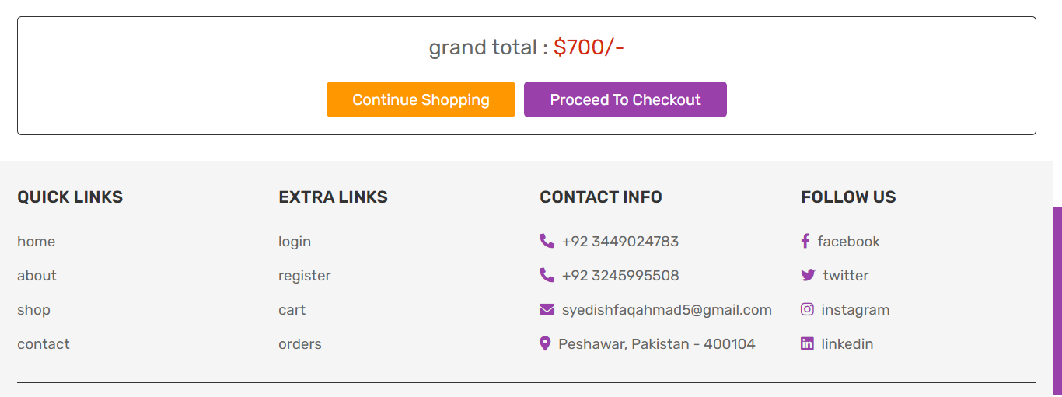

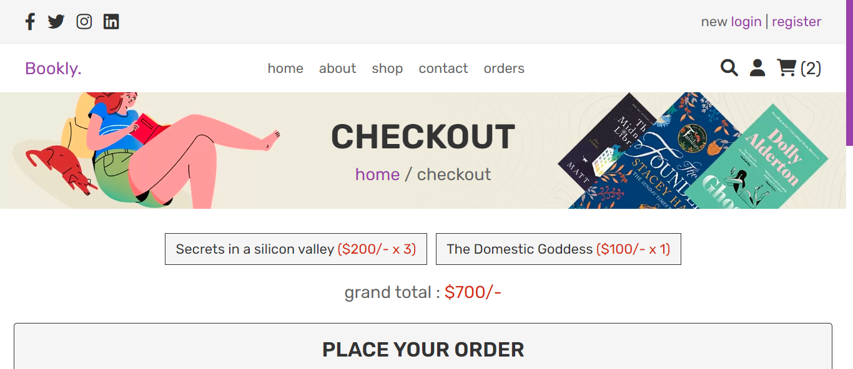 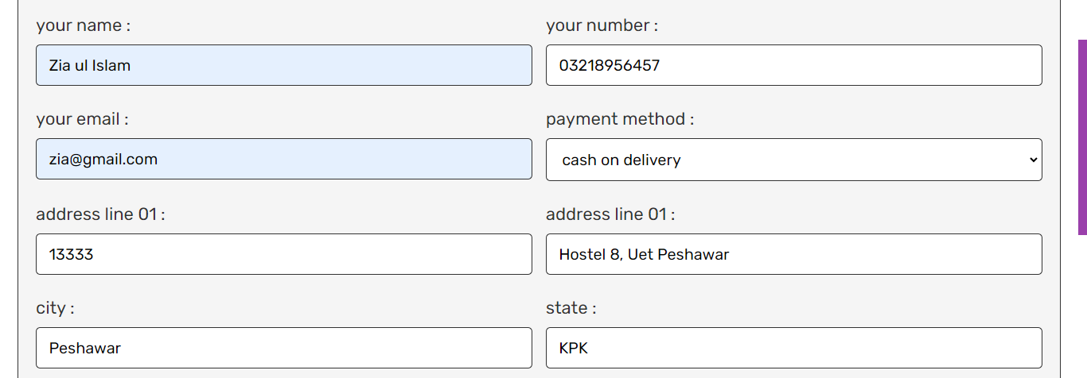 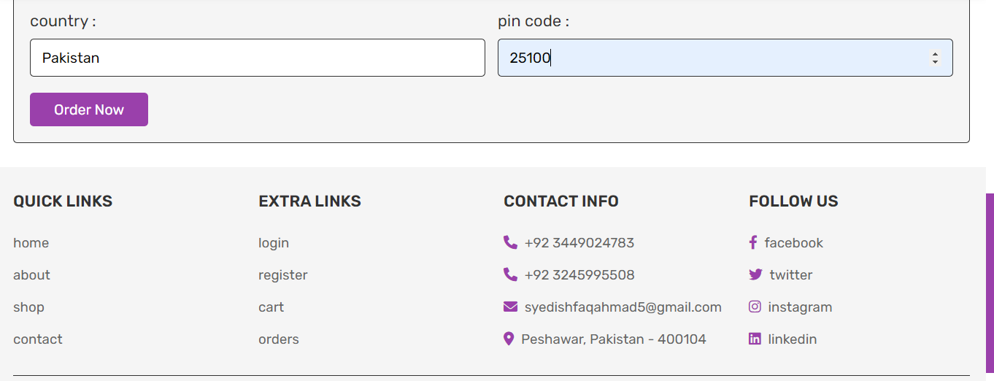

**User Communication:**

Users have the ability to send text messages to the admin regarding any queries, issues, or requests they may have.

The website provides a messaging system for seamless communication between users and the admin.

Preview:

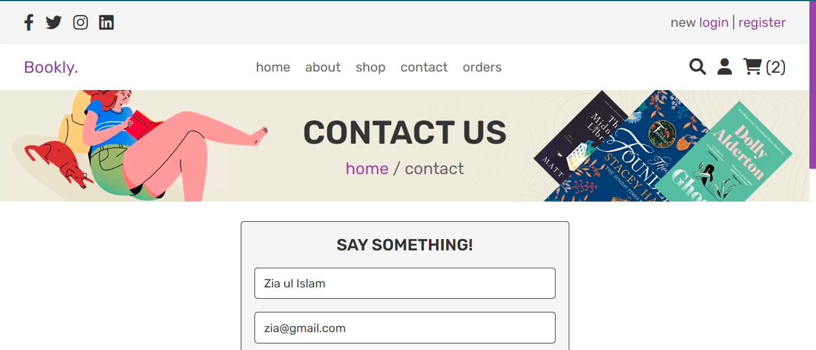 

**Admin Panel:**

* The admin has a dedicated panel with access to advanced functionalities and website management.
* The admin can add new books to the catalog, update book information, and delete books if necessary.
* The admin has the authority to set book prices and modify them as needed.
* The admin can view and accept orders placed by users, update order status, and track order fulfillment.
* The admin can manage user accounts, view user details, and perform necessary actions related to user management.

Preview:

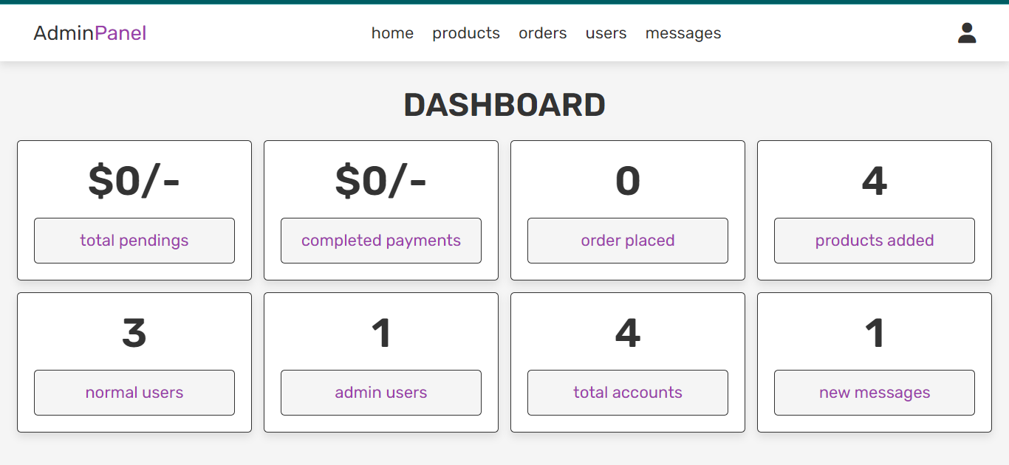

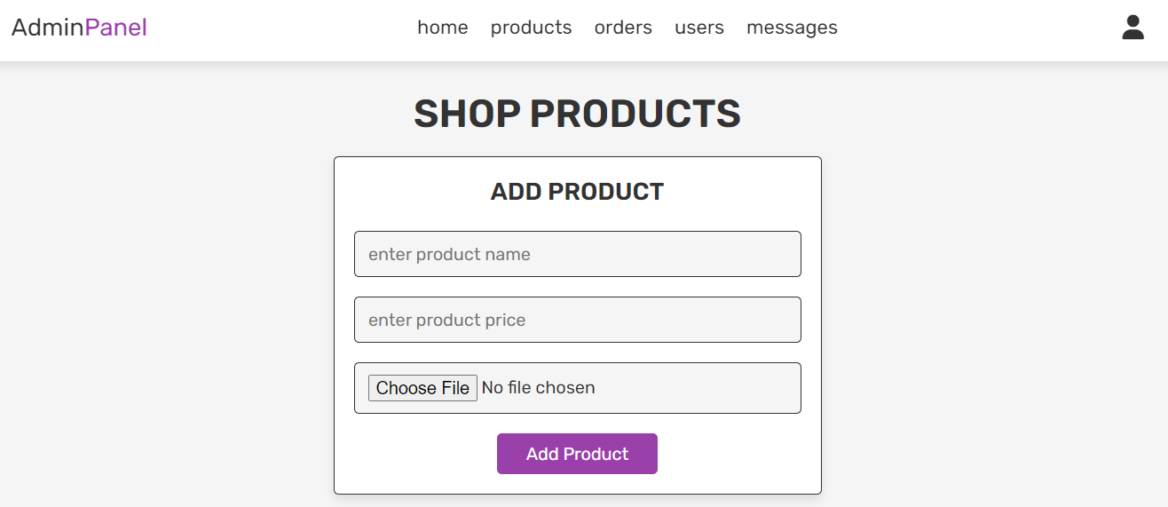

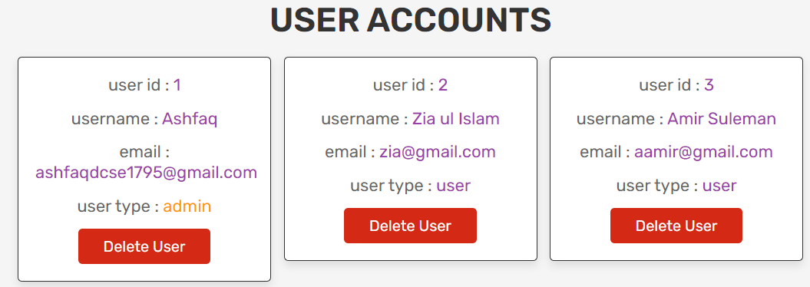

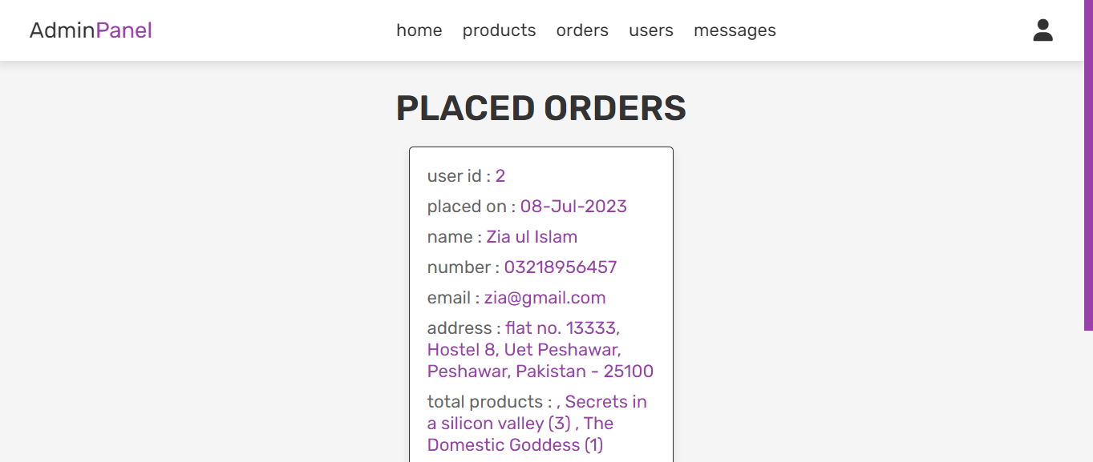 

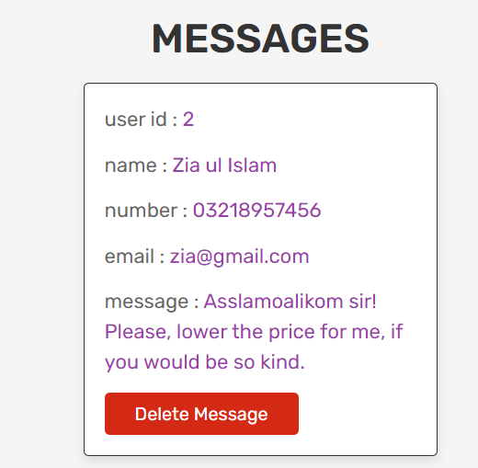

Overall, the Book Store Website provides a convenient and user-friendly platform for users to explore, order, and communicate about books. The admin has full control over book inventory, pricing, and order management, ensuring smooth operations of the website. Whether users are book enthusiasts or avid readers, they can enjoy a seamless experience in browsing and purchasing books through this online platform.